**CITATION: Pacheco, M. (in preparation). Bilingualism-as-participation: Language and literacy competencies across in-school, out-of-school, and on-line contexts. In WIDA-WestEd (Eds.), *Sociocultural contexts of academic literacy development for adolescent English Learners*. Washington, DC: American Educational Research Association.**

*Introduction*

The present research program is driven by a deep interest in shifting deficit-based discourses around English Learner (EL) and bilingual students’ literate competencies and incompetencies in school settings to asset-based discourses that affect strategic forms of assistance, guidance, and support to help these students achieve their academic potential. Despite the current institutionalized emphasis on individually accomplished pre-determined literacy outcomes, this research seeks to document the collaborative literacy activities in which bilingual students participate across contexts. We[1] have begun to document these repertoires in out-of-school and on-line contexts by focusing on bilingual youths’ participation in literacy practices across languages, as well as the roles that co-participants and their assistance play in these processes. While the research is ongoing, I focus here on data collected on one student that we call Sara[2]. I draw on Sara’s case of to demonstrate that across contexts, individuals—including Sara—make distinct accommodations for her biliteracy and bilingualism and are variably committed to expanding her linguistic and academic competencies.

We are particularly concerned that the documentation of EL and bilingual youths’ participation across home-community spaces (for example, Gonzalez, 2001; Gutiérrez, Baquedano-López , Alvarez, & Chiu, 1999; Orellana, 2009; Zentella, 1997, 2005) have minimally re-shaped institutionalized views of literacy as an individually accomplished cognitive process. This focus is reflected in dominant labels that locate competencies and incompetencies *within* individual students (e.g., ‘proficient,’ ‘intermediate’), which affects an overemphasis on changing students rather than changing schooling (Cole, 2005).

*Theoretical Framework*

We view language learning as constituted by individuals’ participation across sociocultural contexts that are mediated by tools, artifacts, everyday practices, joint activities, and goals. Drawing on cultural-historical theoretical perspectives, we conceptualize that learning simultaneously affects and is affected by individuals, including children and youth (Cole, 1996; Vygotsky, 1978). That is, as children and youth creatively and meaningfully participate in particular socioculturally coordinated literacy activities, they help create learning opportunities as they collaborate with others and engage in problem solving. This literacy activity, however, is simultaneously enabled and constrained by broader macro-political circumstances such as educational policy, theories of learning, and ideologies of what ‘counts’ as literacy, for example, across these contexts (Engeström, 1986; Engeström & Sannino, 2010). These broader political and ideological circumstances are especially fundamental to an understanding of the academic experiences of EL and bilingual students whose varied linguistic and cultural experiences are rarely reflected in mainstream schooling (Bartolome, 1994; Darder, 1991).

As macro-contexts shape and affect the character of literacy activity, I believe these theories of learning complement the views of literacy articulated by the New Literacy Studies (NLS) (Gee, 1999; Street, 1993). In this view, a full accounting of joint literacy practices attends to the institutional and power relations within which these practices are embedded inside and outside of school. Street (2005) explains:

If we recognize that literacy practices vary with context and that different practices may be appropriate for different kinds of activity, then we must also recognize that these differences are not simply neutral: The relation between communicative practices is also constitutive of power relations. (p. 11)

These perspectives not only attend to the instantiation of literacy across contexts and settings but also to the socially, culturally, politically, and ideologically constitutive nature of literacy—and academic literacies.

While acknowledging that literacy activities are fluid and complex, a focus on the nature and character of children and youth’s *participation* in literacy activity highlights the ways that teachers and peers facilitate literacy learning and activity in politically- and ideologically-charged contexts. To conceptualize the relationship between participation and learning, we draw on Rogoff’s view of learning as change in participation in the valued but changing activities of cultural communities (Rogoff, 1995, 2003; Gutiérrez & Rogoff, 2003). The appeal of this conceptualization is the empirical and analytic focus on “the efforts of individuals, their companions, and the institutions they constitute and build upon to see development as grounded in the specifics and commonalities of these efforts, opportunities, constraints, and changes” (Rogoff, 1995, pg. 159). Our current theorizing of bilingualism-***as***-participation postulates that youths’ literate and language competencies might be better understood through their changing participation in varied tasks and activities across contexts. A study of changes in participation can illuminate those particular roles and activities that *expand*—or constrain—children and youth’s repertoires and competencies through the strategic forms of assistance, guidance, and support made available in these contexts. Put another way, a participation lens provides a unique way to interrogate how literacy activity is accomplished collaboratively as well as how co-participants help students along the way.

*Related Literature*

We believe this theoretical perspective complements important research from areas such as linguistic anthropology and sociolinguistics that have provided expansive views of bilingualism and biliteracy as they occur *across* and *within* contexts, languages and literacies, discourses, and communities. For example, Hornberger (2003) acknowledges that bilingualism and biliteracy are embedded within particular contexts and settings that make a range of linguistic and literacy demands and instead promotes the continua of biliteracy. She argues that educational policies and programs can promote full biliteracy by engaging students in a range of literacy practices that acknowledge the important role power plays in the divergent valuing of these practices across contexts, content, and media. For example, bilingual students’ home languages are typically valued less than English in U.S. society but valuing both is paramount.

Another body of research has explored ways to leverage bilingual children and youths’ out-of-school translation, Spanglish, and hybrid language practices in home-community spaces and contexts in the service of academic literacies. Building on Orellana’s research (Orellana, Reynolds, Dorner, & Meza, 2003), she and her colleagues have worked collaboratively with teachers to develop and implement language arts curricula that leverage bilingual youths’ everyday translation activities in the service of writing (Maritnez, Orellana, Pacheco, & Carbone, 2008; Orellana & Reynolds, 2008). Some of this research has documented the unique political-historical knowledge practitioners could examine further in their attempts to build on students’ everyday literacy and language practices (Pacheco, 2009, 2012). Gutiérrez and her colleagues demonstrate that when students are encouraged to utilize hybrid language practices to engage in literacy activity in an after-school club, bilingual children were able to access a broader, richer repertoire of literacy and language capabilities (Gutiérrez et al., 1999). Similarly, Moll, Saez, & Dworin (2001) demonstrate that providing frequent opportunities for students to access what the researchers call their English and Spanish “social worlds” allows them to demonstrate a richer repertoire of literacy skills, and writing in particular. Finally, Moschkovich (2002) and Jimenez, García, & Pearson (1996) have demonstrated that bilingual-biliterate students have a wealth of skills, resources, and meta-linguistic awareness they deliberately and strategically employ in the service of mathematical sense-making and successful English reading, respectively.

This brief discussion of empirical research is by no means exhaustive. It does, however, begin to illustrate that bilingualism and biliteracy are situated and socioculturally constructed across individuals, contexts, and settings for meaningful purposes and that they have significant consequences for academic literacies. Because EL and bilingual students participate across a range of language and literacy activity in out-of-school contexts, their social, cultural, and intellectual resources are amplified when their languages are unmarked and leveraged deliberately in educational settings.

We hope the present research study might extend this important empirical research. Namely, we hope to document bilingual youths’ participation in language and literacy activity across in-school, out-of-school, and on-line contexts and focus our analysis on the coordinated efforts of their co-participants, including their assistance, guidance, and support.

*Research Questions*

The research questions guiding this ongoing study are as follows. First, how do youth employ their bilingualism as they accomplish various tasks—in English and Spanish—across in-school, out-of-school, and on-line contexts? Second, what roles do peers, teachers, and other adults play in the participatory process and in language-expanding activities in these contexts, including the types of assistance, guidance, and support they provide pertaining to these roles?

*Methods*

We employ ethnographic methods to study bilingualism and biliteracy (Heller, 2009)—though studying youths in their classrooms is currently pending. While we have recruited six participants, data has only been collected on three. Specifically, we have undertaken participant observations of youths’ participation in routine language and literacy activity. We have also undertaken informal interviews, document collection, photography, and audio-recorded formal interviews in students’ home-community spaces to substantiate the character of everyday language and literacy activity (Cresswell, 2009; Heath & Street, 2008). Inductive data analyses have centered on the collaborative efforts of individuals and co-participants across contexts and how challenges and difficulties are mediated through particular forms of assistance, guidance, and support, especially as these pertain to routine language and literacy activity (Miles & Huberman, 1994).

**Findings**

*A Preliminary Example*

For this paper, I focus on Sara who was a 9th grader when we began data collection. She is a former early-exit transitional bilingual education student but is now in English mainstream classes, including some Honors classes. Her case provides an opportunity to examine the long-term schooling experiences of a student who is considered fluent English proficient and academically “successful.” Importantly, data analyses reflect that indeed Sara is developing a conscious awareness about the politically- and ideologically-embedded nature of language, literacy, and schooling.

*Biliteracy at Church*

One context where clear accommodations were made for Sara and her family’s bilingualism and biliteracy was at their local church, which was formerly English-only. In particular, their participation—and the participation of a growing number of Spanish-speaking families—was accommodated in recent years through the concurrent translation of songs and sermons as well as the fluid use of Spanish and English across congregation members. Greetings across languages were commonly heard (e.g., *¡Buenos dias!*). Together, these language practices were organized deliberately by the pastor and his advisors to keep bilingual youth, who preferred English, engaged in religious worship with their parents. Their priority, in other words, was the joint worship between youth and their parents and the concurrent translation practices were coordinated to facilitate these relationships in the religious community.

*Teen Newspaper*

Sara also participated at a community-based teen newspaper where students wrote about a broad range of assigned and self-selected topics. Most youth participated in the community-based program for several years and some participated through their middle and high school careers. Over time, youth could participate as novice and expert journalists, teen editors, and editorial staff members who oversaw the work of more novice journalists. A dominant activity was the writing conference between adults and peers. In this English-dominant newsroom, language practices were mediated by routine collaborative writing that provided students robust opportunities for assistance with journalistic writing, content, and learning.

Table 1 represents my coding of four writing conferences between Sara and several staff members, and shows the article topics as well as the skills addressed during these conferences.

Analyses show that assistance with journalism was quite diverse at the teen newspaper office. It was facilitated by a range of individuals with varied levels of journalism expertise, content-based articles that created distinct challenges and learning opportunities for her, and a focus on the skills needed to enhance her writing. Depending on the nature of the article or complexity of the topic, Sara received assistance considering her audience and making more effective and appropriate word choices. The point here is that while this English-only newspaper did not provide opportunities for Sara to employ her full linguistic repertoire, there was a readily available network of assistance, guidance, and support unique to this literacy and writing context.

*Bilingualism On-line*

Sara used very different forms of writing on-line, mostly on Facebook. In an analysis of her language use, data show that she used mostly English. However, she also used Spanish, codeswitching, and Internet slang fairy regularly as well as employed multimodal resources such as links, emoticons, images, and punctuation in her writing.

The content, topics, and discourses she used on Facebook were varied as she, for example, quoted song lyrics and added links to the videos, as well as pretended to be a rapper. Here I copied a quote from an Elvis Presley song and a sample of Sara’s rapping:

* Highlighting song lyrics
  + For what is a man, what has he got? If not himself, then he has naught. To say the things he truly feels, and not the words of one who kneels. (Elvis Presley, *My Way*)
* Being a “rapper”
  + Yoo I’m [Sara], yeah yeah, bored trynna write an essay but I can’t (no no.) So instead imma waste my time trynna rap LOL hahaha snaP! Ayyyyyye!

Additionally, Sara and her friend joked about a sign that read “For Lease Navidad,” which is a play on the Christmas greeting in Spanish, “Feliz Navidad” (see Appendix A). Joking across languages and her and her friends’ regular codeswitching reflected these youths’ hybrid language and literacy practices. I emphasize, however, the varied tools Sara employed in her literacy practices—popular culture, the oral and written discourse of rap, and the manipulation of bilingual discourses to engage in word play. Moreover, these language and literacy practices on Facebook appeared to be distinct from Sara’s language and literacy practices in other contexts.

Table 2 represents a coding of Sara’s language practices in relation to the topics that emerged among her on-line friends, with illustrations of this usage.

For example, she used Internet slang across languages to modify the spelling of “beans” and used common acronyms such as LMS for “like my status.” Importantly, Facebook provided a flexible, co-constructed linguistic and literacy space for individuals to demonstrate a repertoire of languages and identities—for example, a runner, a joker, and a Christian, which allowed Sara to appropriate the various specialized languages and literacy practices associated with these particular identities (e.g., a Mexican “beaner” identity by using “beansz” in her writing).

*Bilingualism at Home*

At home, observations and informal interviews with Sara’s mother, Mrs. Alvarez, revealed her commitment to her children’s Spanish-language maintenance. To this end, the parents spoke Spanish only, while the toddler son spoke mostly Spanish and Sara spoke English almost exclusively. The family also read and discussed the Bible in Spanish on a weekly basis but schoolwork was a source of tension, which I will discuss in a later section. Thus, language was deliberately distributed across individual family members and across literacy practices (e.g., reading the Bible in Spanish).

Furthermore, Mrs. Alvarez viewed language as a way to impart cultural heritage and values to her children, as the following vignette illustrates.

Vignette 1: *“Nuestra Cultura”* [Our Culture]

During one observation, Sara’s mother asked about my religion. I briefly explained to Sara and her mother that I’d be Catholic as long as my mother lived. Sara remarked that *she* wouldn’t remain Catholic simply for her mother. Her mother then responded, *“En nuestra cultura se acostumbra que los padres se honran sobre todo. Y honrar a tus padres es una manera de honrar a Dios”* [In our culture, it is customary to honor parent above all else. And to honor your parents is one way to honor God]. Sara interjected, “That’s why I love America!”

Sara’s mother took opportunities like this one to impart views of “*nuestra cultura*” as Mexicans, which she also imbued with Christian values. That is, Mrs. Alvarez associated honoring one’s parents as a way of honoring God, while Sara associated a disregard for her mother with being “American.” This examples shows that for Mrs. Alvarez, deliberately and actively expanding Sara’s bilingualism and biliteracy in the home space was linked to issues of religious and cultural identity, assimilation processes, and values and worldviews. However, one literacy practice Mrs. Alvarez could not mitigate because of her limited English was Sara’s schoolwork.

*School Artifacts*

In the family home, I came across many of Sara’s school artifacts. These documents provided opportunities to understand her schooling experience, ascertain her awareness about the kinds of languages and literacies valued in school, and her ongoing struggles as an ostensibly “successful” English-proficient student. I was particularly struck by one document—a history review provided by Sara’s 9th grade history teacher (see Appendix B). Sara’s jottings reveal strategies she used to access the task, or make it comprehensible.

Document analyses show that this task required intensive problem-solving on Sara’s part, which reveals as well her appropriation of ways to make sense of incomprehensible English-language texts such as this one. One strategy was to underline unknown words and phrases and to provide a dictionary definition as shown below in Image 1, a portion of the history review (see Appendix C).

Image 1: Ratify



In this example, she underlined the word “ratify” and then defined it on the side as “confirm approval by.” She also embedded definitions within definitions, as illustrated in Image 2:

Image 2: Popular Sovereignty

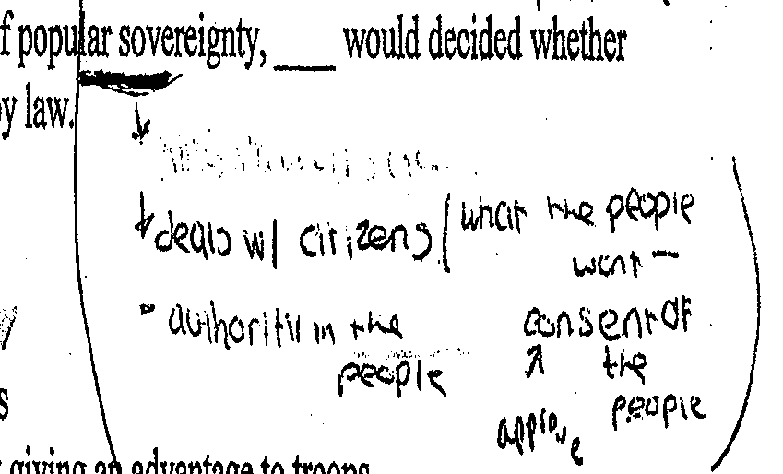

She underlined “popular sovereignty” and proceeded to copy several dictionary definitions. One definition was that it “deal w/ citizens” and “authority in the people” followed by her own embedded definitions of “what the people want” and “consent of the people.” Additionally, she defined “consent” as “approve,” using parentheses to delineate the dictionary definitions as well as her own.

Importantly, Sara also engaged in meaning making as she attempted to make the text comprehensible relative to her current language repertoire. Image 3 and 4 shown below are taken from a third page of the history review (see Appendix D). After including a dictionary definition for “inferior” as “less powerful…opposite of superior,” as is visible in Image 3, she also added her own phrasing that “on top more powerful.”

Image 3: Inferiors



It is important to emphasize that Sara was actively engaged in problem solving as she utilized available material resources (e.g., a dictionary) to comprehend the text and simultaneously attempted to make sense of the perplexing dictionary definitions. When I asked Sara about her jottings, she confirmed that “on top more powerful” was her definition of “superior.” Thus, it appears that she was self-monitoring her own comprehension of the text, employing her knowledge to make sense of nebulous dictionary definitions.

Lastly, document analyses show that she occasionally misapplied strategies as well. In Image 4 below, she seems to have incorrectly defined “anti-draft” as “not rough draft or final.”

Image 4



Thus, it appears that Sara had limited resources to confirm her estimations and misestimations and that these missteps perhaps jeopardized her academic success. Nevertheless, it is clear that she appropriated strategies to resolve an incomprehensible English-language history review.

Table 3 represents my document analysis of Sara’s strategies for comprehending the history review, including the codes I generated with illustrative examples.



These strategies show that for Sara to participate fully in this task, or to reap the full benefits of this history review, she was on her own and found minimal forms of assistance at home or school. I discussed this artifact with her to confirm my interpretations and get clarifications. During this discussion, she explained that she relied on Internet resources to understand the history review and other similar school tasks (i.e., on-line dictionaries, Wikipedia, Ask.com) as well as other less common strategies, which I listed in the shaded boxes in Table 3. Sara also expressed, however, some personal reflections about language, literacy, and learning.

*Sara’s Reflections: “The Words are Like the Content”*

In attempting to gain a deeper understanding of the different ways Sara participated across out-of-school and on-line contexts, it became clear during formal and informal discussions that she was increasingly aware about the fundamental relationship between language, literacy, and content as well as the importance of developing problem-solving strategies to attain academic success. Furthermore, she expressed intense levels of distress about her challenges with English academic language, literacy, and content area tasks.

During one audio-recorded discussion, Sara reflected, “I know these words aren’t gonna go away and I know I’m not just gonna magically understand every single word… I feel like if I just keep working on it, then I’ll know enough to get through.” I then asked, “Are you still struggling with the vocabulary or the content or both?” She replied, “Both cus I think the words are like the content cus most of the time when I don’t understand what a word means, it’s because that’s the main part of the whatever I’m reading and so that’s the content. And I’m like, well how am I supposed to understand this if I don’t know what the word means?”

Later in our discussion, Sara conceded, “I reached a breaking point. I thought, *no one else* has to do this, why do *I* have to do this? I’m not trying to conform or anything, you know. But it’s like I’m tired.” She finally revealed that, “I failed English and I’m re-taking it cus I didn’t do the essays. And I didn’t do the essays cus we had to use big words and I don’t like big words cus I got sick and tired of looking them up.” Thus, the demands placed on Sara to be able to participate fully and successfully in school tasks and activities were taking their toll and intensifying her sense of distress, as well as her mother’s sense of helplessness.

*Discussion*

Preliminary analyses reveal that the particular roles, practices, & assistance available across contexts helped constitute Sara’s academic and linguistic competencies and *incompetencies*. In some contexts, individuals deliberately shaped and accommodated her bilingualism and biliteracy in a deliberate attempt to include her—and her family—as full community members (i.e., her church). In other contexts, Sara found variable opportunities to access the kind of help, assistance, guidance, and support she needed. It is evident that individuals across these sociocultural contexts and institutions were variably committed to enhancing her repertoire of languages, literacies, and identities, as reflected in their practices of assistance, support, and guidance.

*Conclusion*

As we continue this research, we hope to document the availability of resources & accommodations (positive *and* negative) that facilitate competence in and outside of school to better understand EL and bilingual youths’ developmental trajectories. While we seek to fully account for the ways that power and ideology saturate bilingual and biliteracy practices across contexts in and outside of school (Gee, 1999; Street, 1993, 2005), we are particularly interested in documenting the assistance, guidance, and support that affect how youth with varying capabilities and needs participate to varying degrees in these spaces (Rogoff, 1995, 2003). Additionally, it seems that we must consider with more seriousness the relevant perspectives EL and bilingual youth develop about their academic struggles, especially in gatekeeping English mainstream content area classrooms. In acknowledging the political and ideological circumstances within which language and literacy practices are embedded, it seems necessary to ascertain the extent to which EL and bilingual-biliterate youth are also developing a conscious awareness and perhaps even a critique of the ways their experiences and knowledges are marginalized or privileged in and outside of school. Finally, we hope this research can substantiate the ways that a participation lens might inform curriculum approaches and language programs for EL and bilingual youth. Such approaches might shift discourses about EL and bilingual youths’ deficits to discourses centered on the specific types of assistance, guidance, and support educators coordinate and make available to help these youth achieve their potential.

**References**

Bartolomé, L. (1994). Beyond the methods fetish: Towards a humanizing pedagogy. *Harvard Educational Review, 64*(2), 173-194.

Cole, M. (2005). Cross-cultural and historical perspectives on the developmental consequences of education. *Human Development, 48*, 195–216.

Cole, M. (1996). *Cultural psychology: A once and future discipline*. Cambridge, MA: Harvard University Press.

Creswell, J.W. (2009). *Research design: Qualitative, quantitative, and mixed methods approaches* (3rd Ed.). Thousand Oaks, CA: Sage Publications, Inc.

Darder, A. (1990). *Culture and power in the classroom: A critical foundation for bicultural education*. Westport, CT: Bergin & Garvey.

Engeström. (1986). The zone of proximal development as the basic category of educational psychology. *The Quarterly Newsletter of the Laboratory of Comparative Human Cognition, 8*(1), 23-42.

Engeström, & Sannino, A. (2010). Studies of expansive learning: Foundations, findings and future challenges. *Educational Research Review, 5*(1), 1-24.

Gee, J. P. (1999). *An introduction to discourse analysis: Theory and method*. London and New York: Routledge.

Gonzalez, N. (2001). *I am my language: Discourses of women and children in the borderlands*. Tuczon, AZ: The University of Arizona Press.

Gutiérrez, & Rogoff, B. (2003). Cultural ways of learning: Individual traits or repertoires of practice. *Educational Researcher, 32*(5), 19-25.

Gutiérrez, Baquedano-López, Alvarez, & Chiu. (1999). Building a culture of collaboration through hybrid language practices. *Theory into Practice, 38*(2), 87-93.

Heath, S.B. & Street, B.V. (2008). *On ethnography: Approaches to language and literacy research*. New York: Teachers College Press and National Council of Research in Language and Literacy.

Heller, M. (2009). Doing Ethnography. In *The Blackwell Guide to Research Methods in Bilingualism and Multilingualism* (pp. 249-262): Blackwell Publishing Ltd.

Hornberger, N. (2003). Continua of biliteracy. In *Continua of biliteracy: An Ecological Framework for Educational Policy, Research, and Practice in Multilingual Settings* (p. 3-34). Tonawanda, NY: Multilingual Matters, Ltd.

Jimenez, R., Garcia, G. E., & Pearson, D. (1996). The reading strategies of bilingual Latina/o students who are successful English readers: Opportunities and obstacles. *Reading Research Quarterly, 31*(1), 90-112.

Martinez, R. A., Orellana, M. F., Pacheco, M., & Carbone, P. (2008). Found in translation: Connecting translating experiences to academic writing. *Language Arts, 85*(6), 421-431.

Miles, M. B., & Huberman, A. M. (1994). *Qualitative data analysis* (2nd Ed.). Thousand Oaks, CA: Sage Publishers.

Moll, L.C., Saez, R., & Dworin, J. (2001). Exploring biliteracy: Two student case examples of writing as a social practice. *The Elementary School Journal, 101*(4), 435-449.

Moschkovich, J. (2002). A situated and sociocultural perspective on bilingual mathematics learners. *Mathematical Thinking and Learning, 4*(2 & 3), 189-212.

Orellana, M.F. (2009). Translating childhoods: Immigrant youth, language, and culture. Piscataway, NJ: Rutgers University Press.

Orellana, M. F., Reynolds, J., Dorner, L., & Meza, M. (2003). In other words: Translating or “paraphrasing” as a family literacy practice in immigrant households. *Reading Research Quarterly, 38*(1), 12-34.

Pacheco, M. (2009). Expansive learning and Chicana/o and Latina/o students’ political-historical knowledge. *Language Arts, 87*(1), 18-29.

Pacheco, M. (2012). Learning in/through everyday resistance: A cultural-historical perspective on community ‘resources’ and curriculum. *Educational Researcher, 41*(4), 121-132.

Rogoff, B. (2003). *The cultural nature of human development*. New York: Oxford University Press.

Rogoff, B. (1995). Observing sociocultural activity on three planes: Participatory appropriation, guided appropriation, and apprenticeship. In J. V. Wertsch, P. Del Rio & A. Alvarez (Eds.), *Sociocultural studies of mind* (pp. 139-164). Cambridge: Cambridge University.

Street, B. (1993). Introduction: The new literacy studies. In B. Street (Ed.), *Cross-cultural approaches to literacy* (pp. 1-22). Cambridge: Cambridge University Press.

Street, B. (2005). *Literacies across educational contexts: Mediating learning and teaching*. Philadelphia: Caslon Publications.

Vygotsky, L. S. (1978). *Mind in society: The development of higher physchological processes*. In M. Cole, V. John-Steiner, S. Scriber & E. Souberman (Eds.). Cambridge, MA: Harvard University Press.

Zentella, A. C. (1997). *Growing up bilingual*. Malden, MA: Blackwell Publishers.

Zentella, A.C. (2005). *Building on strength: Language and literacy in Latino families and communities*. New York: Teachers College Press.

**Appendix A**



**Appendix B**

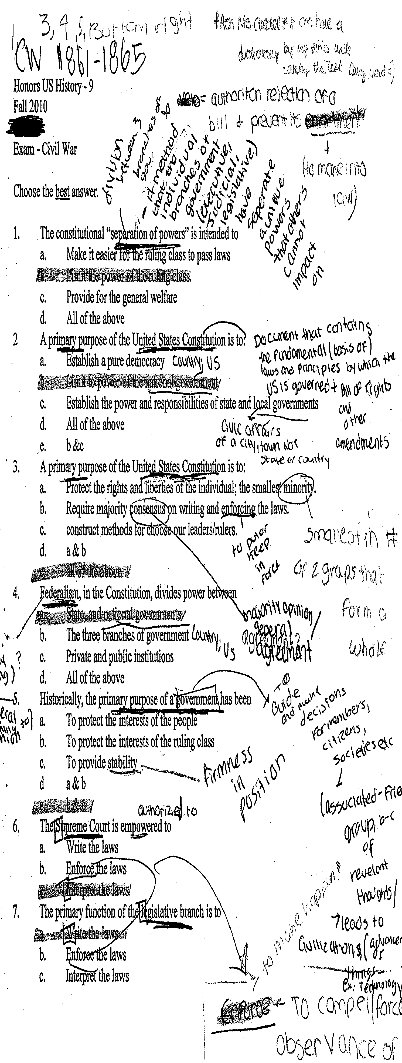

**Appendix C**

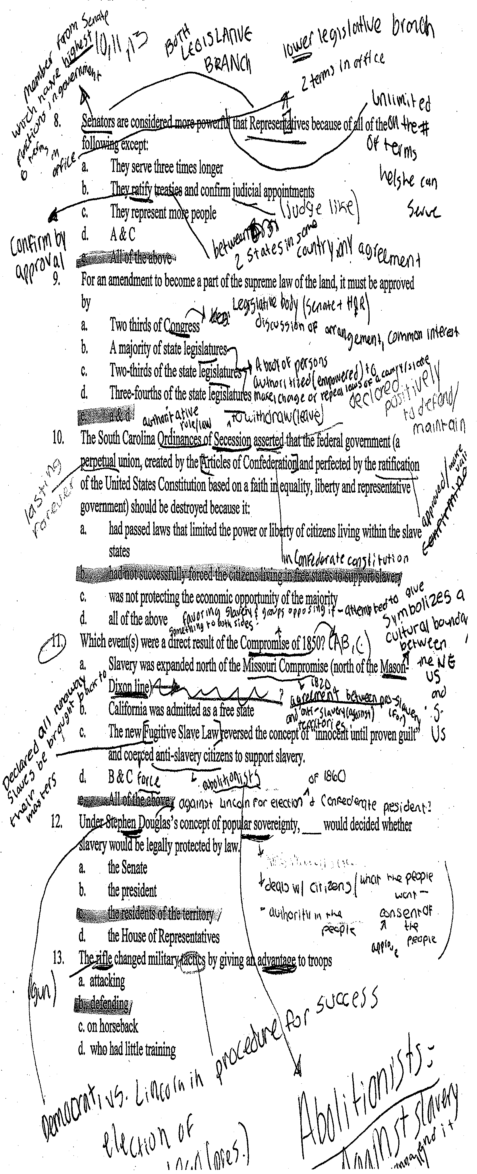

**Appendix D**

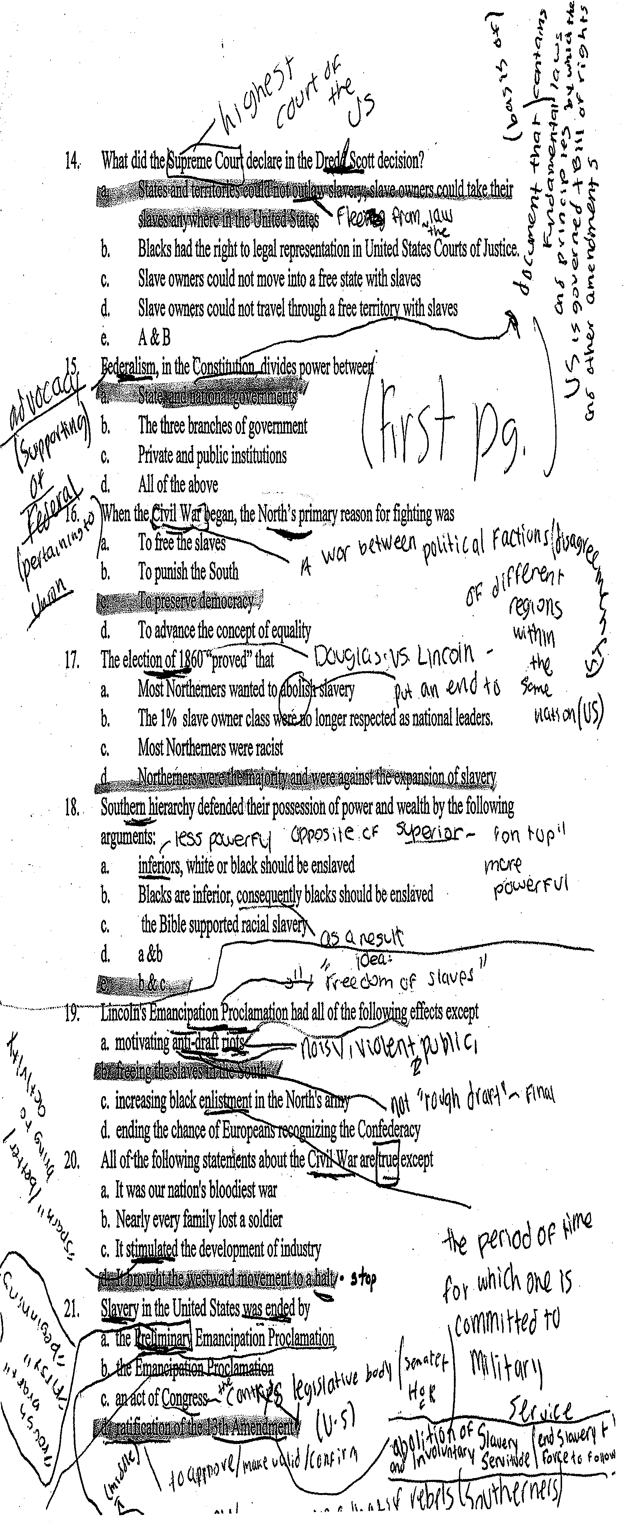

1. I have thought through some of these theoretical ideas with Patricia Venegas and Jennifer Wilfrid, also from UW-Madison.
2. All names are pseudonyms.